International Rally Drivers Club
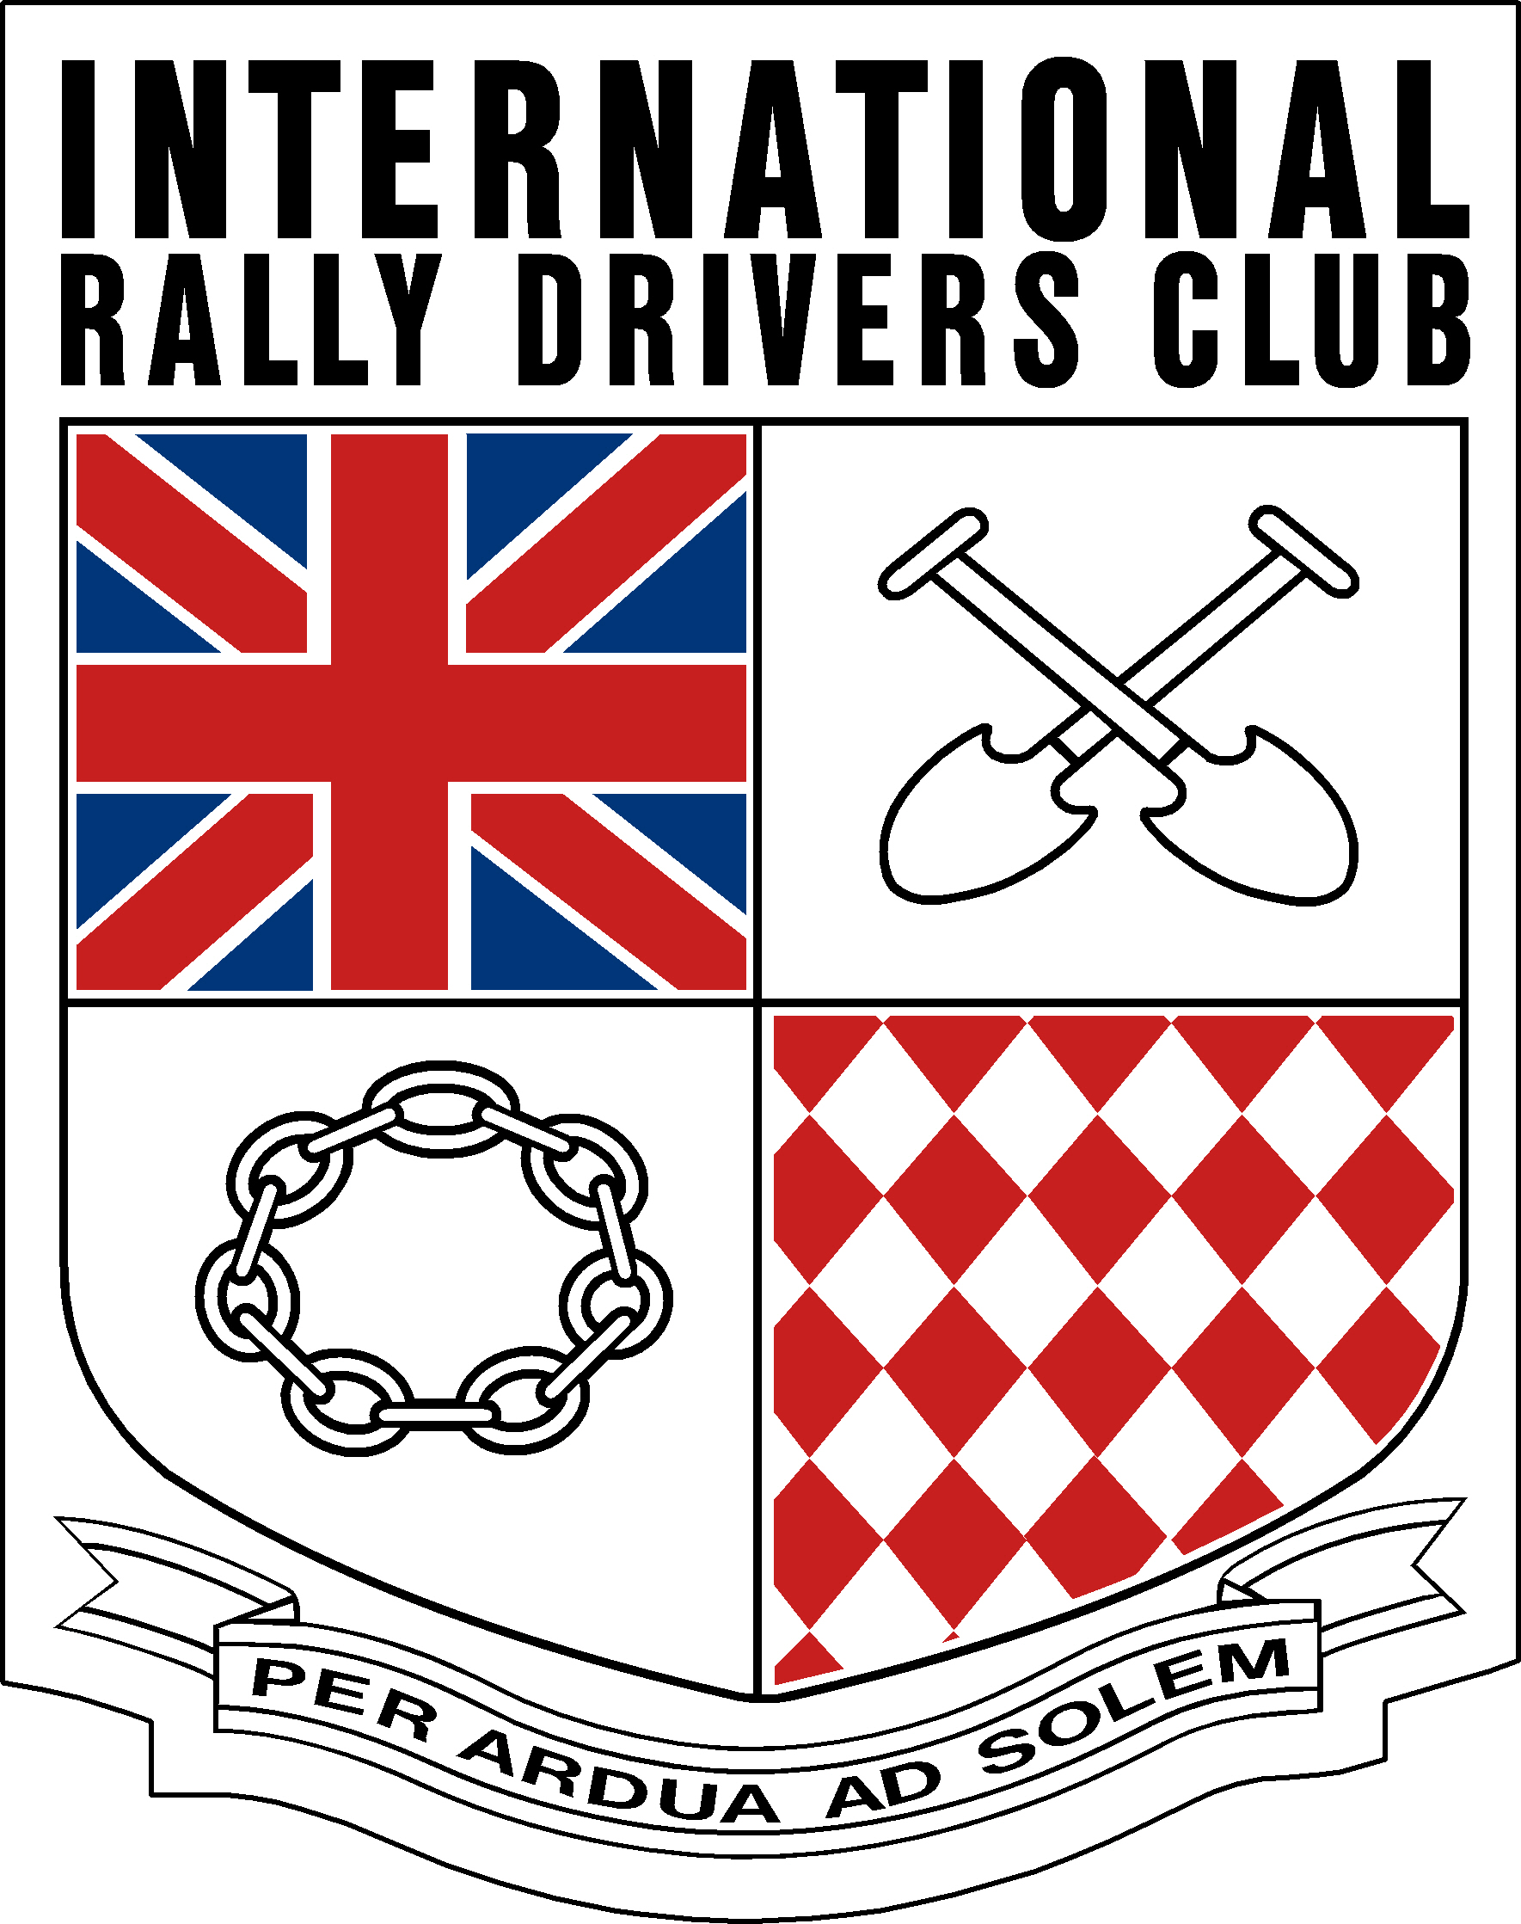

Membership Application form

THIS APPLICATION IS A [PLEASE DELETE WHICH IS NOT APPLICABLE] NEW / RENEWAL / LAPSED

Membership is open to all competitors who have (a) started at least one International Rally, or (b) have started one National rally under the jurisdiction of a National organisation other than the National organisation which issued their competition licence, or (c) A genuine love for the sport of Rallying (forms will be screened for suitability)

Please complete in BLOCK CAPITALS
Surname..................................Dr/Mr/Mrs/Miss.....................Initials.............. First name.................................
Address.......................................................................................................................................................................................................................................................................................................................................................................................................................................................................................................................
…................................................................................Postcode …..................... Country....................................
Telephone, Office………………………………………………..... Home…………………………………........................................... Mobile……………………………………………………………………
Occupation ……………………………………………………………..E-mail………………………………………………………………………….
……………………………………………………………………………………………………………………………………………………………………..
Please give details of the most recent National or International rally that you have started:
Rally…...................................................................................................................Year …..................................
How did you hear of the IRDC………………………………………………………………………………………………………………………
Are you prepared to help with the administration of the Club? Yes/No………………………………………………………

Please complete the Bankers order details (this is the best method for the club)
To: ………………………………………………………………….Bank PLC : Account number……………………………………………….. Sort Code ________-________-__________
Full address of bank ….....................................................................................................................................................................................................................................................................................................................................................Postcode……………………………………………PAYMENT REF…………………………………………………………………………………..
Please pay Barclays Bank PLC, 75 High Street, Brentwood (20-12-21) for the Credit of the International Rally Drivers Club account number
00516929, the sum of £19.00 (nineteen pounds) and debit my account accordingly, now and on the first day of this month in each subsequent year until cancelled by me in writing.
Please ensure that you quote the reference_______________________________ When making payment.
Or enclose a cheque for the subscription of £19.00 made payable to the International Rally Drivers Club
In all cases please return the form to: IRDC Membership, 25 Heol y Plas, Fforest, Pontardulais. Swansea. SA4 0TY UK Or email to; IRDC.membership@outlook.com And sign
I confirm payment as detailed above and apply to join the International Rally Drivers Club in accordance with the Constitution and Rulesand authorise my details to be published in printed and/or electronic form.
Signed _____________________________________________Date _______________________________

